First import the data set by going to Get Data 🡪 Excel then browse the dataset. Select all the tables and click on Load.

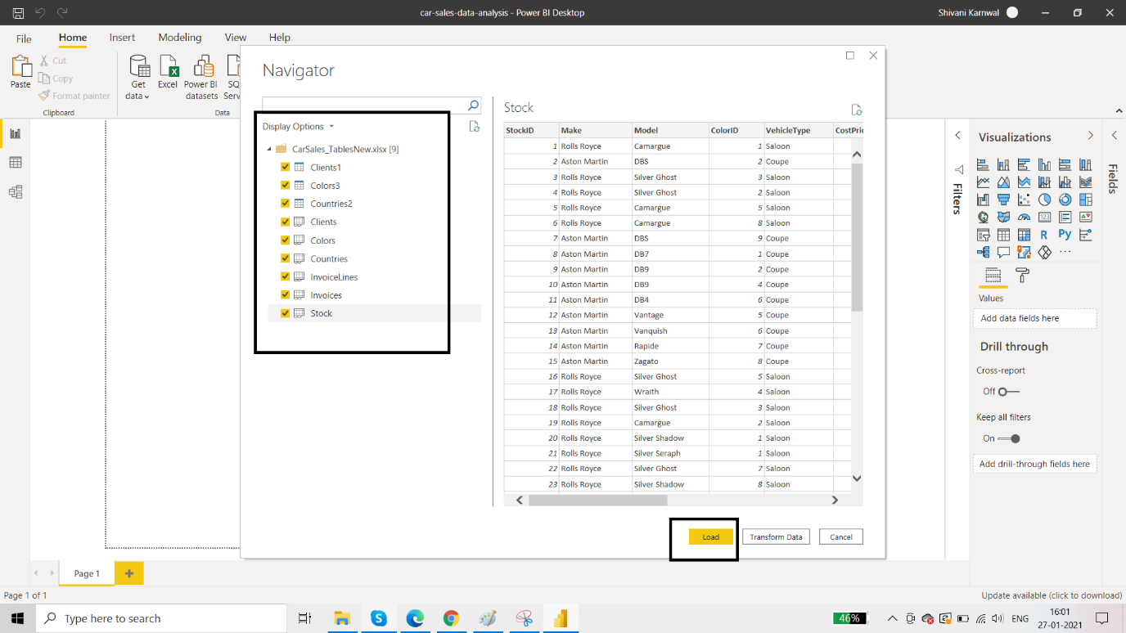

**Requirement 1: Create a new Date Table using DAX**

We have many tables in our data model but there is no proper date table. So, we have to create a date table considering the dates we have in other columns. We have dates in Invoices table and Stock table only.

If you observe the dates column carefully, you can see that the dates are ranging between the years 2012 to 2015. Let’s use this range to create a Date Table through the below navigation.

Go to data view and click on New Table. Name it as Date Table. Then use the following DAX functions to create columns in the table:

Date Table = CALENDAR("01-01-2012","31-12-2015")

Full year = FORMAT('Date Table'[Date],"yyyy")

Full Month = FORMAT('Date Table'[Date],"MMMM")

Month Number = FORMAT('Date Table'[Date],"MM")

Quarter Number = QUARTER('Date Table'[Date])

Quarter = "Q"& QUARTER('Date Table'[Date])

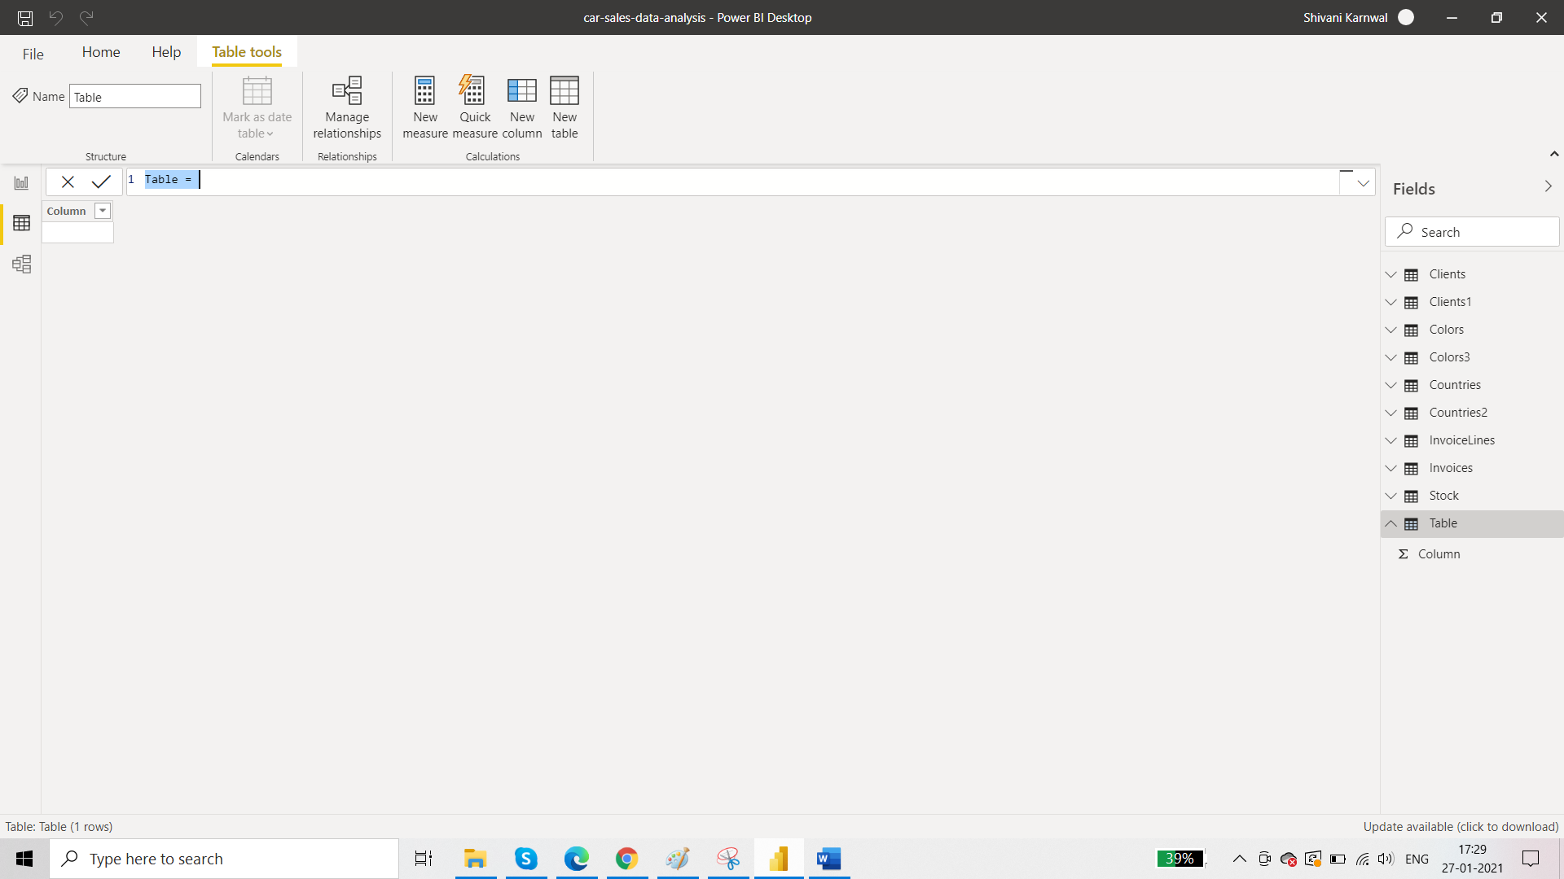

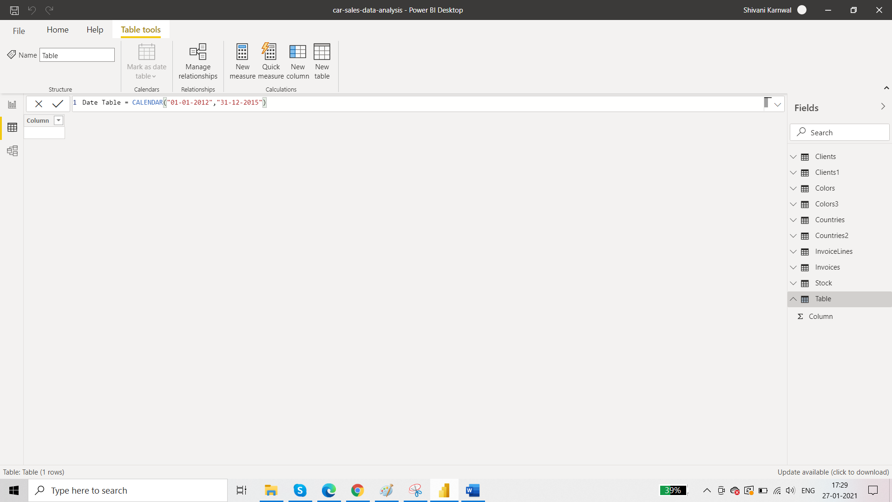

Your Date Table will look like this:

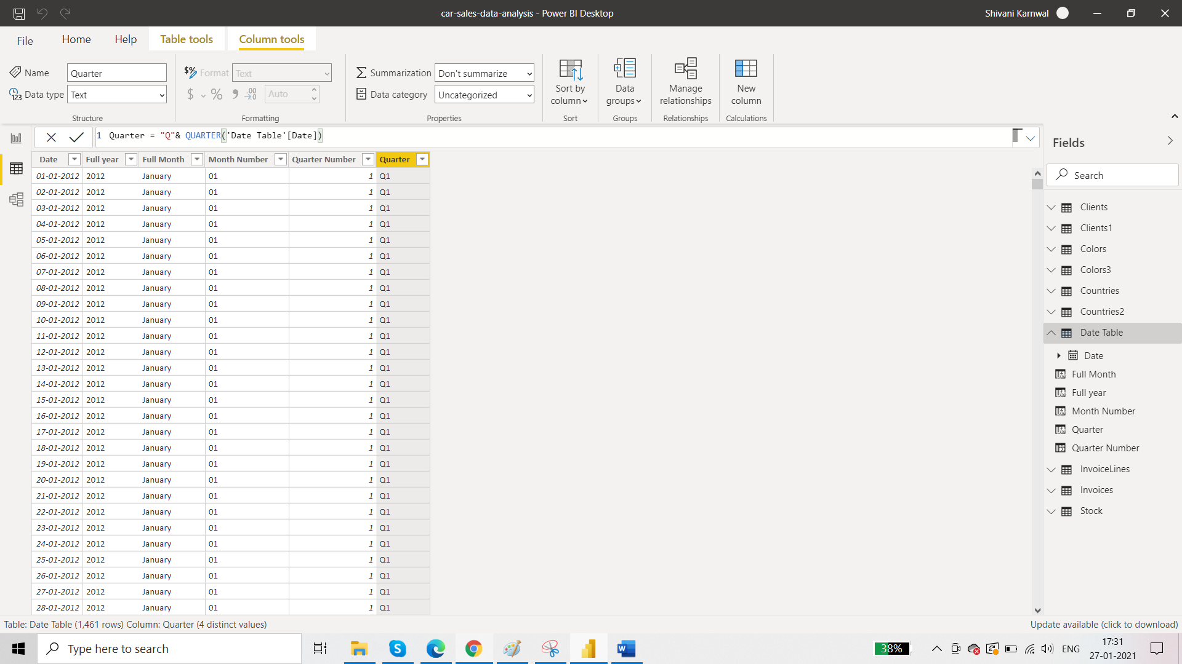

Now the most important part regarding a date table.  Power BI does not identify the **DATE** table unless we *"Mark as a Date table"* through the table tools option. Change data type and rename DATE column to "dd-mm-yyyy" format.

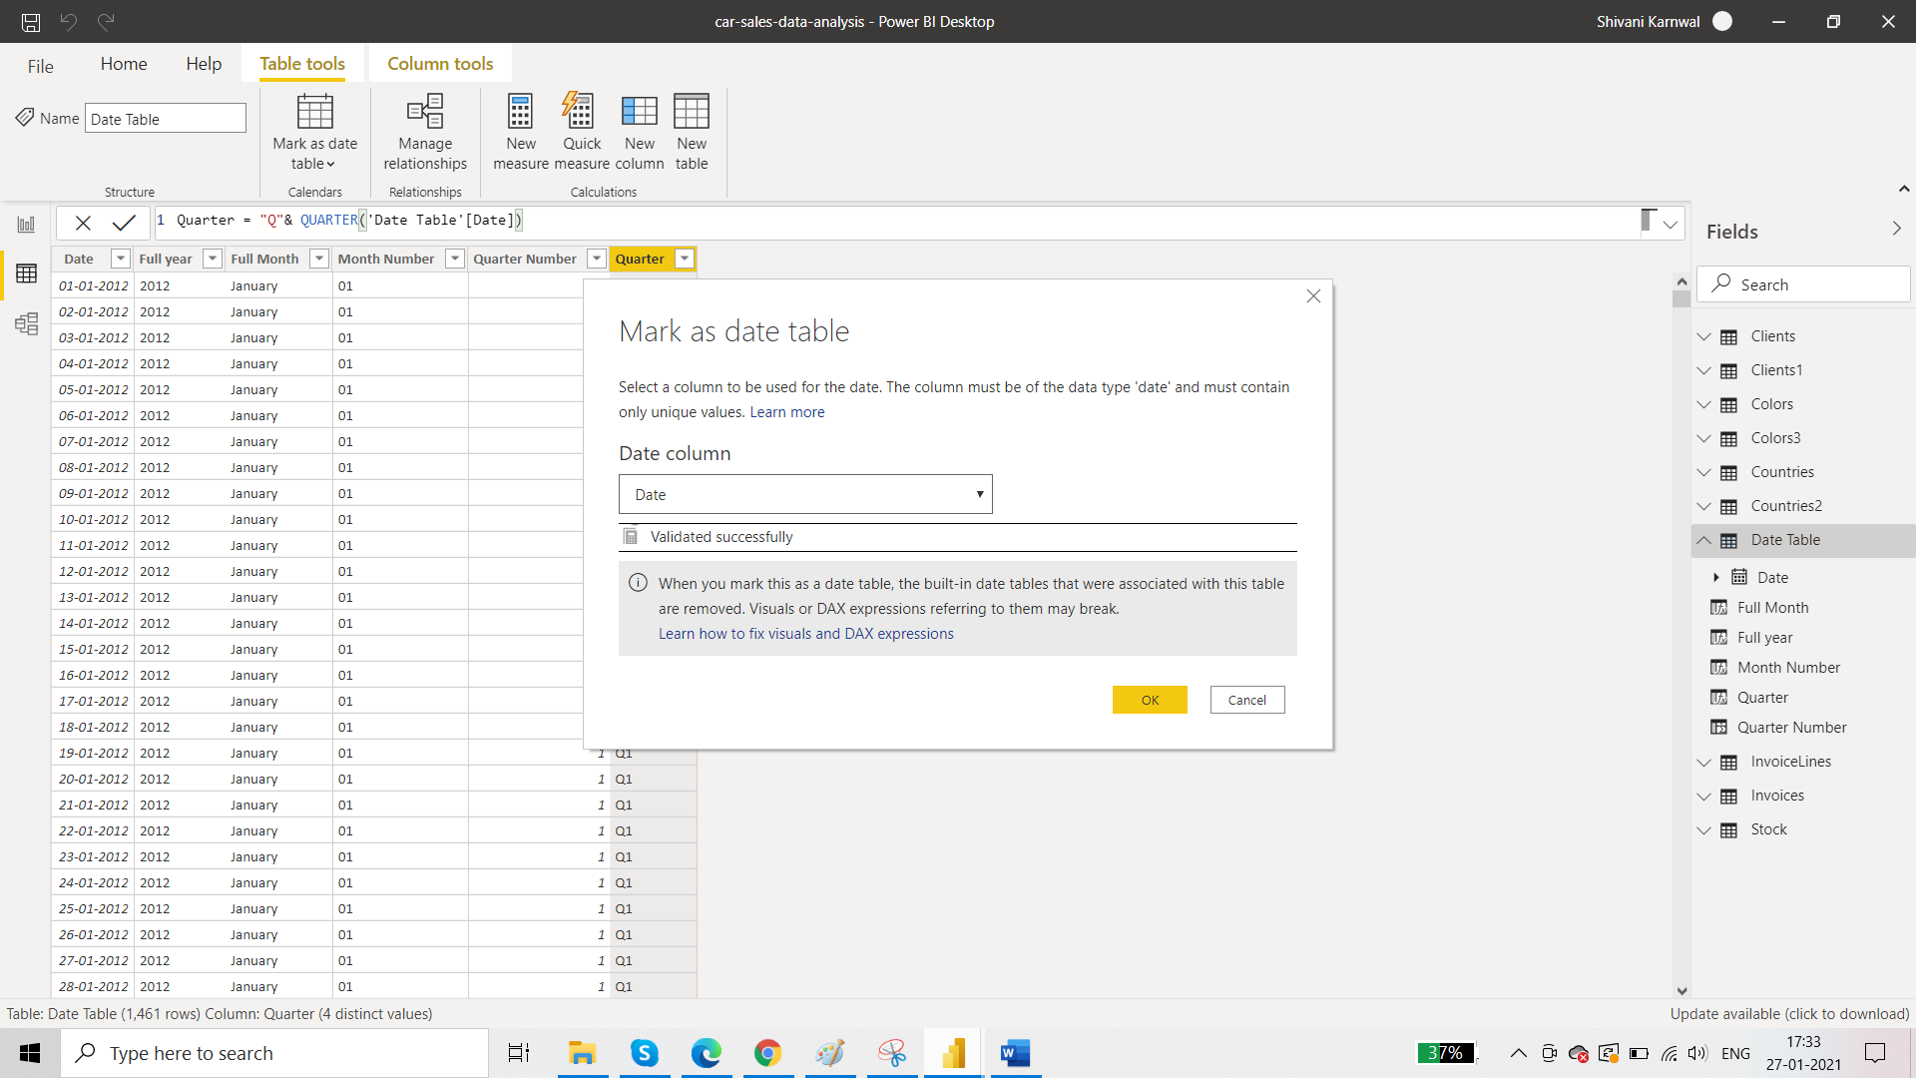

**Requirement 2: Create a new measure to find the quarterly sales**

Create a measure table. From report view, go to home tab and click enter data then name the table as ‘Imp Measures’

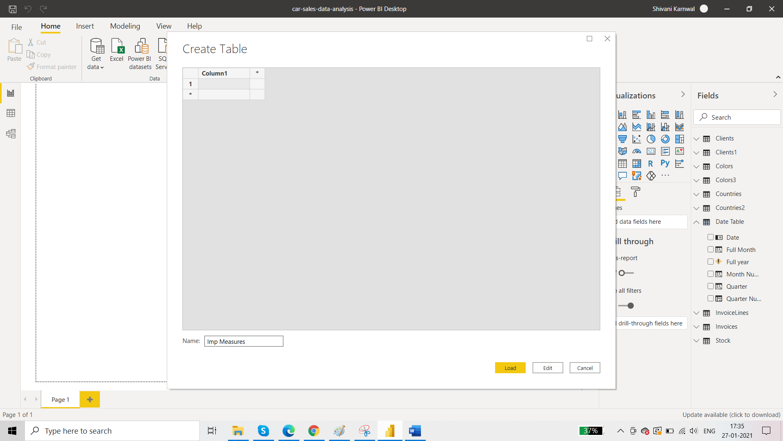

Now click on new measure. Add the measure for quarterly sales:

Quarterly Sales = CALCULATE(SUM(InvoiceLines[SalePrice]),DATESQTD(Invoices[InvoiceDate]))

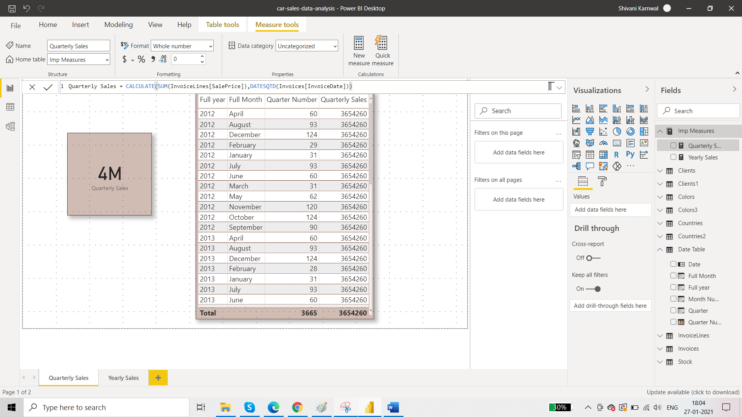

**Requirement 3: Create a new measure to find the yearly sales.**

For the measure table, again add new measure:

Yearly Sales = CALCULATE(SUM(InvoiceLines[SalePrice]),DATESYTD(Invoices[InvoiceDate]))

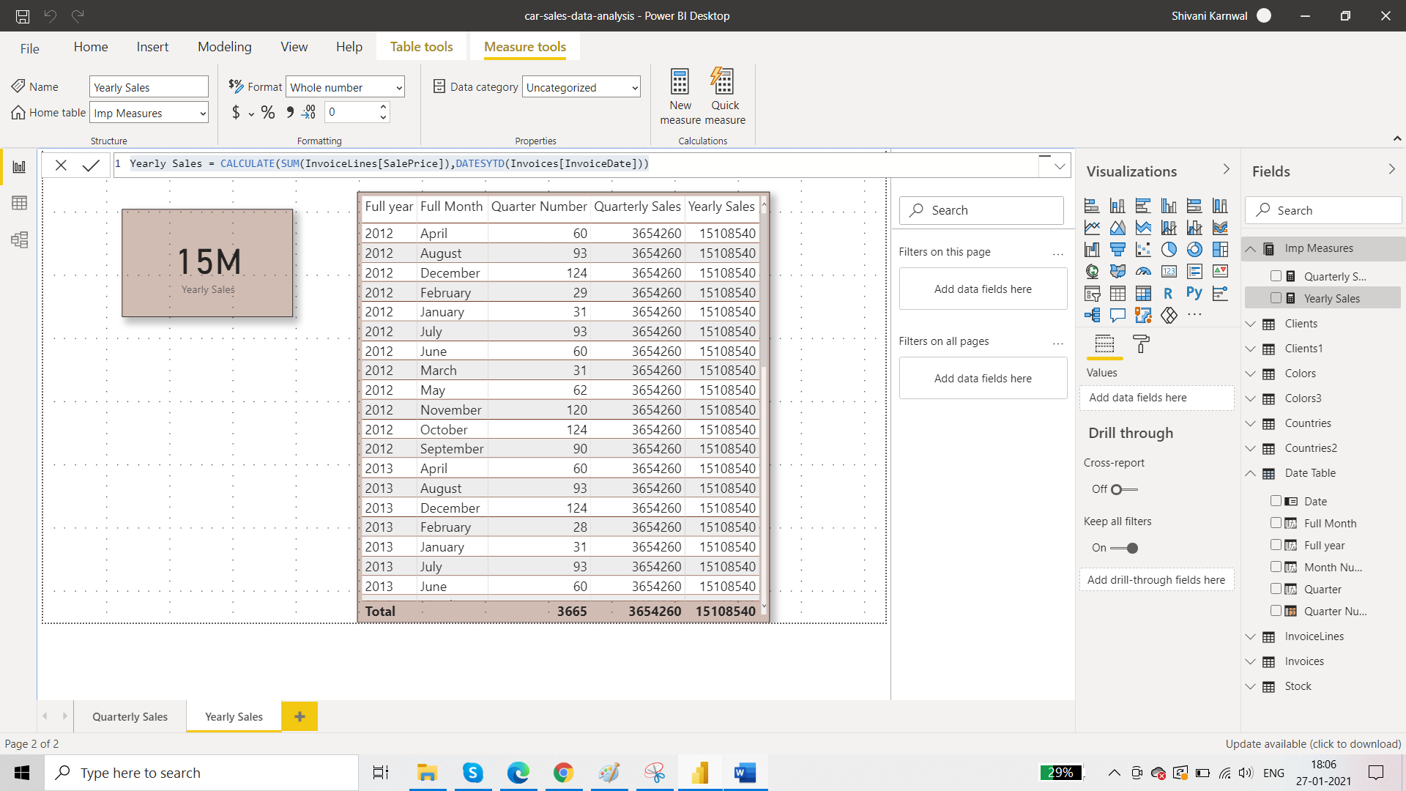

**Requirement 4: Create a new table called Fact_Sales containing the data as follows**

Fact_sales = SELECTCOLUMNS(InvoiceLines,"SalePrice", InvoiceLines[SalePrice],

"CostPrice", RELATED(Stock[CostPrice]),

"SpareParts", RELATED(Stock[SpareParts]),

"LabourCost", RELATED(Stock[LaborCost]),

"InvoiceDate", RELATED(Invoices[InvoiceDate]) )

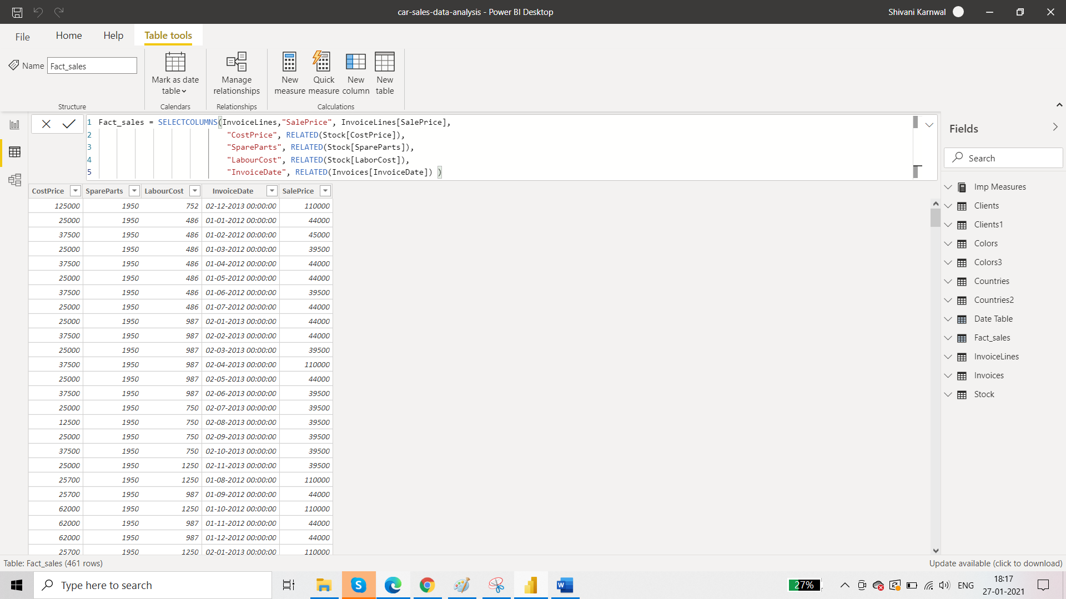

Use the following dax formulas to further enhance date table. The formulas are as follows

Date Table = CALENDAR("01-01-2012","31-12-2015")

Full year = FORMAT('Date Table'[Date],"yyyy")

Full Month = FORMAT('Date Table'[Date],"MMMM")

Month Number = FORMAT('Date Table'[Date],"MM")

Quarter Number = QUARTER('Date Table'[Date])

Quarter = "Q"& QUARTER('Date Table'[Date])

Month Abbr = FORMAT('Date Table'[Date],"MMM")

Week no. = WEEKNUM('Date Table'[Date],2)

Day no. = Day('Date Table'[Date])

Day Name = FORMAT('Date Table'[Day no.],"DDD")

Your date table will look like this:

